FS-8705-49

Emmerson ROC TLP
Ethernet Driver
Also known as
ROC 180/181 Driver

Description

This Ethernet driver implements ROC Opcode services 180 and 181. It supports all (non-text) parameters of all possible Point Types (TLP’s) . The driver supports ROC legacy and ROC800. Using this driver the gateway can read and write data using TLP’s. The driver also supports the reading of data indirectly. Ie TLP’s can point to other TLP’s.

Driver supports various ROC devices.

Non-Plus – ROC300 Series with ROCPAC / FLASHPAC
Floboss 102 / 104 / 107 / 407 / 503 /504
RegFlow
ROC800 Devices
ROC800L
ROCplus
Production Manager
Well Optimization … And all other devices that have TLP tables.

Like other drivers this driver can be couple with any of the other 120+ protocols in our library. Thus ROC data may be monitored and controlled using Rockwell Family, Modbus Family , GE Family of protocols as well as BACNet family, Lonworks, SNMP, and many more building and automation protocols.

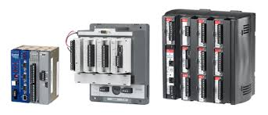

Block Diagram
Multiple upstream protocols and connection supported. See list of FieldServer Drivers.

Max Nodes Supported
FieldServer Mode | Nodes | Comments
Active Client | 20 | A max of ?? ROC devices per gateway  Upper limit is determined by gateway memory and speed. This has been tested with up to 20 devices. The same code used in another project supported hundreds of devices.

Formal Driver Type
Ethernet using TCP/IP
Active Client
This driver can also be used to emulate one or more ROC devices. Said another way. If you want a BACnet / Modbus / Rockwell etc device to respond to ROC messages – Chipkin has that covered.

Compatibility Matrix

FieldServer Model | Compatible with this driver
All legacy products (FS2010/4010/3510) | Yes,
All current products as at July 2020 | Yes,
EZ Gateways, QuickServer, Quickserver classic, Multiport Gateways | Yes,

Devices tested

Device | Tested (FACTORY, SITE)
Various | 2020 Feb – Office Lab with purchased devices and software  2020Jul – Customer site in US. Multiple types of devices. A large ROC network.

Driver is Future Proof
This driver has been written in such a way that should new devices or Point Types, the driver will be capable of supporting them without new firmware, simply by means of configuration.

Services Supported
All options of Command, Query and Responses of each service supported

Opcode
180 – TLP Read
181 – TLP Write
10,11,99 for read and write of indirect variables.
We have another driver which supports the other Opcodes. Ask our sales dept.

Data Type Supported
Supports all known Data Types for ROC Plus, ROC800, ROC Legacy ….
The following table is updated from time to time on our web site. It is not updated int his document
Google “ROC by Chipkin DATA TYPES SUMMARY xls” to get the latest. There is support for proprietary vendor types too.

File maybe found here: https://store.chipkin.com/articles/roc-by-chipkin-data-types-summary-xlsx
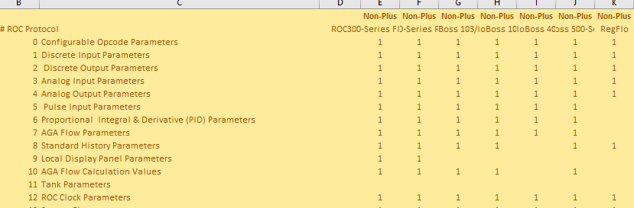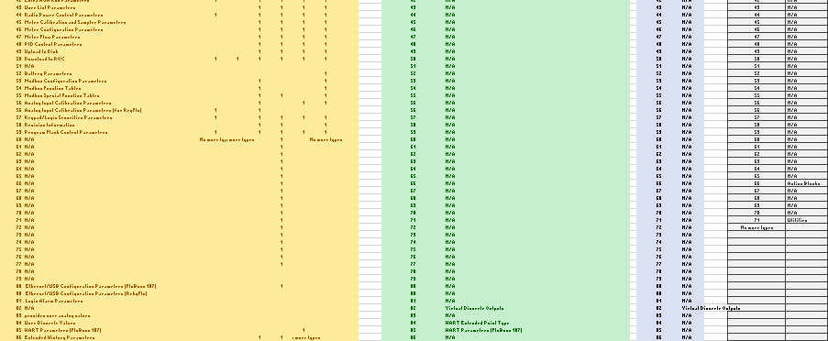

ROC Opcodes

The Chipkin ROC Opcode driver is available. It can be coupled with this driver. Part number = 8705-50

Support

Please contact Chipkin Automation Systems directly for driver support.

Revision History

Date | Resp | Format | Driver Ver. | Doc.  Rev. | Comment
2020Jul | PMC |  | 0.00 | 0 | Created.

